I did binning on the amount column. 0-5 amount one bin and i assumed this would mean low asset specificity, 5-20 one bit and i assumed this would mean medium asset specificity, 20 and above one bin and i assumed this would mean high specificity.

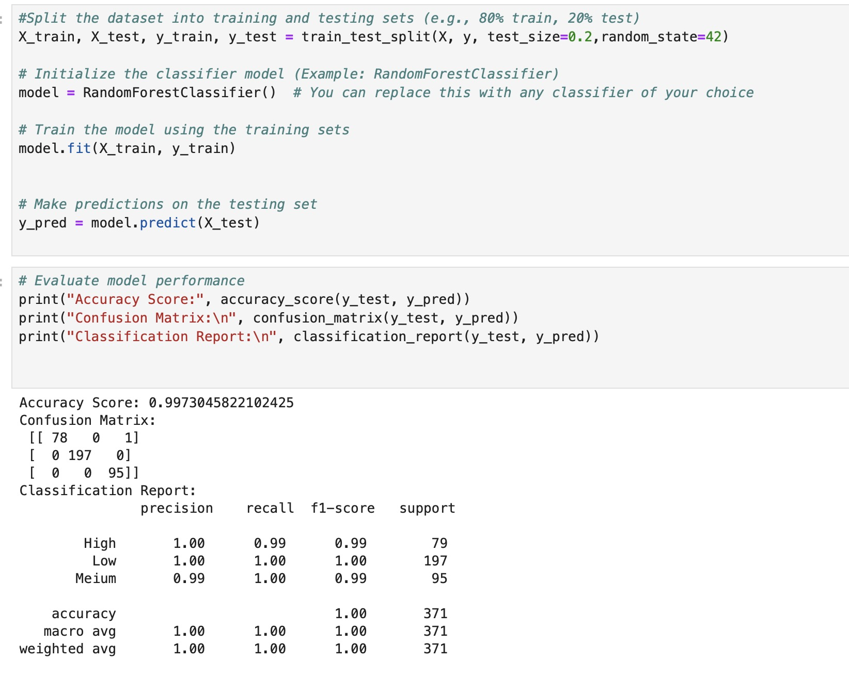

1. \*\*Accuracy Score\*\*: The model achieved an accuracy score of approximately 99.73%, which indicates a very high level of accuracy in its predictions.

2. \*\*Confusion Matrix\*\*: The confusion matrix shows how the model's predictions matched against the true values. In this case, we have a 3x3 matrix, which suggests there are three classes. The matrix indicates that the model made very few misclassifications. Specifically, there was just one instance where a data point from the first class (High) was misclassified as the third class (Meium, which seems to be a typo for 'Medium').

3. \*\*Classification Report\*\*:

- The precision for 'High' is 1.00, indicating no false positives for this class.

- The recall for 'High' is 0.99, suggesting that nearly all true 'High' instances were correctly identified.

- The F1-score for 'High' is 0.99, which is a weighted average of precision and recall and is also very high.

- The 'Low' class has perfect scores across precision, recall, and F1-score, indicating perfect performance for this class.

- The 'Meium' class has a precision of 0.99, a recall of 1.00, and an F1-score of 0.99, showing very high performance but with a slight precision reduction compared to 'Low'.

- The 'support' is the number of true instances for each class in the dataset, with 79 for 'High', 197 for 'Low', and 95 for 'Meium'.

Overall, the model is performing exceptionally well across all classes with a very high accuracy rate and excellent precision, recall, and F1-scores. The only noticeable errors are a single misclassification of 'High' as 'Meium' and the typo in the class name 'Medium'.

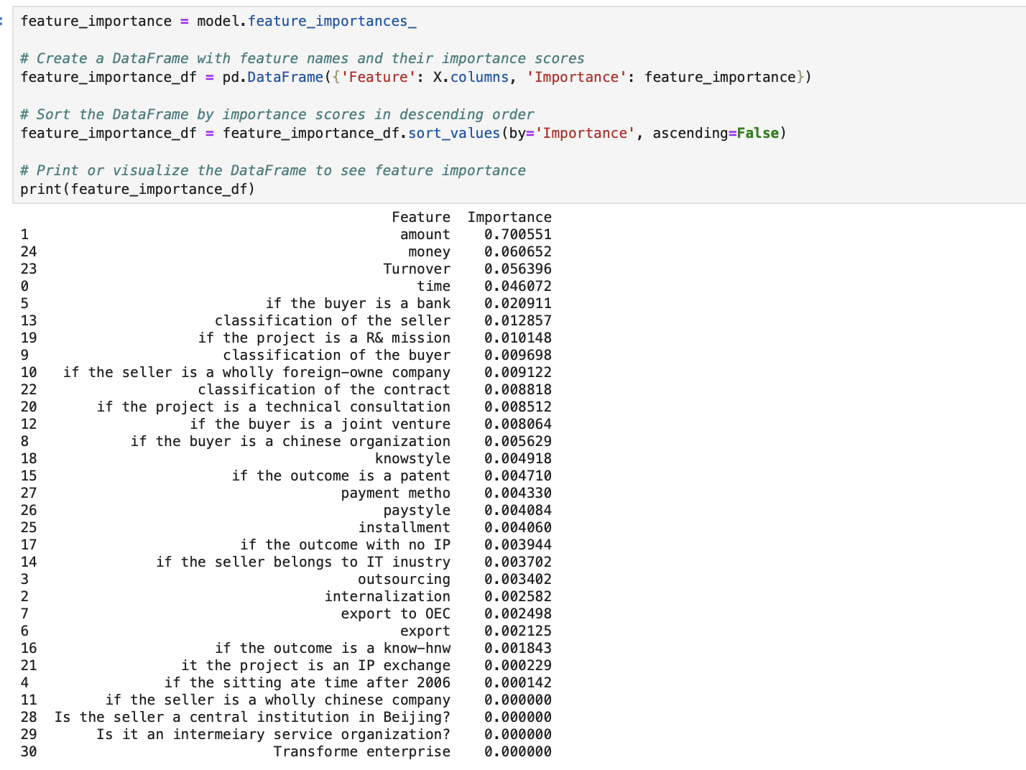

From the sorted list, we can see that the feature named 'amount' has the highest importance score of approximately 0.76, suggesting that it is the most influential feature in the model's predictions. The feature named 'money' follows with an importance score of approximately 0.08. Several features, such as 'Turnover', 'time', and 'if the buyer is a bank', have lower but significant importance scores ranging from 0.05 to 0.02. Many features, particularly from row 16 downwards, have importance scores of zero, indicating they did not contribute to the model's decision-making process in this particular training instance.

Non-IT companies often require specialized skills for specific tasks that are not part of their core expertise. Outsourcing allows them to access a pool of skilled professionals without the need to hire and train an in-house team. In the IT industry, some functions, such as software development or cybersecurity, may be closely tied to the company's core competencies, leading them to keep these functions in-house.Non-IT companies often have a broader range of business functions that can be outsourced globally. This is especially true for manufacturing, customer service, and back-office operations. IT companies may still outsource, but they may prioritize partnerships or collaborations with other tech firms rather than relying extensively on third-party service providers.Some non-IT industries, such as healthcare or finance, have stringent regulatory requirements. Outsourcing certain functions may involve risks related to data security and compliance. IT companies, particularly those dealing with sensitive information, may be more cautious about outsourcing to ensure compliance with industry regulations.

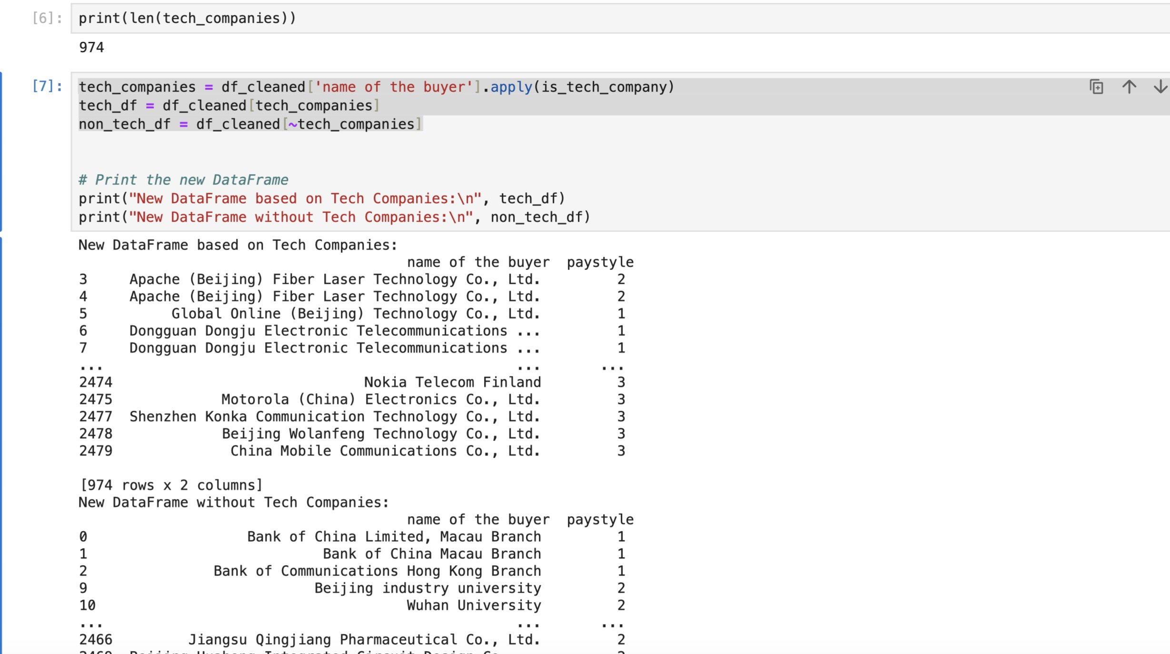

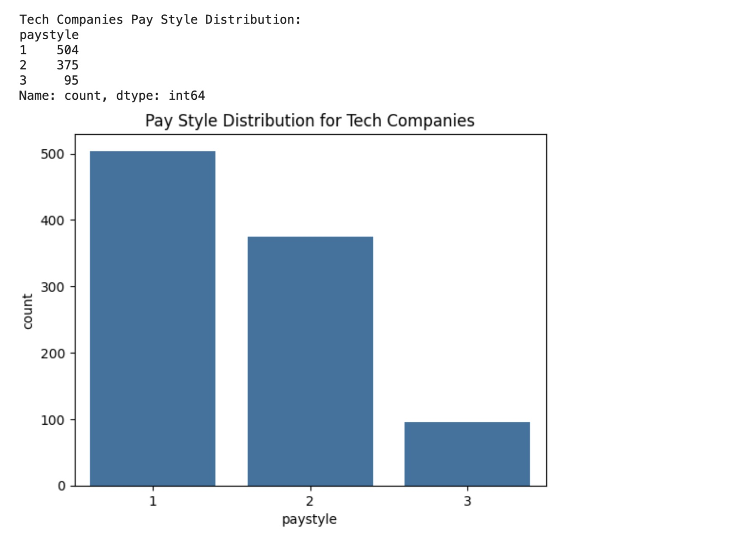

this is the tech companies pay style distribution. 1 means Installed Payment, 2 means One time payment and 3 means commission payment.

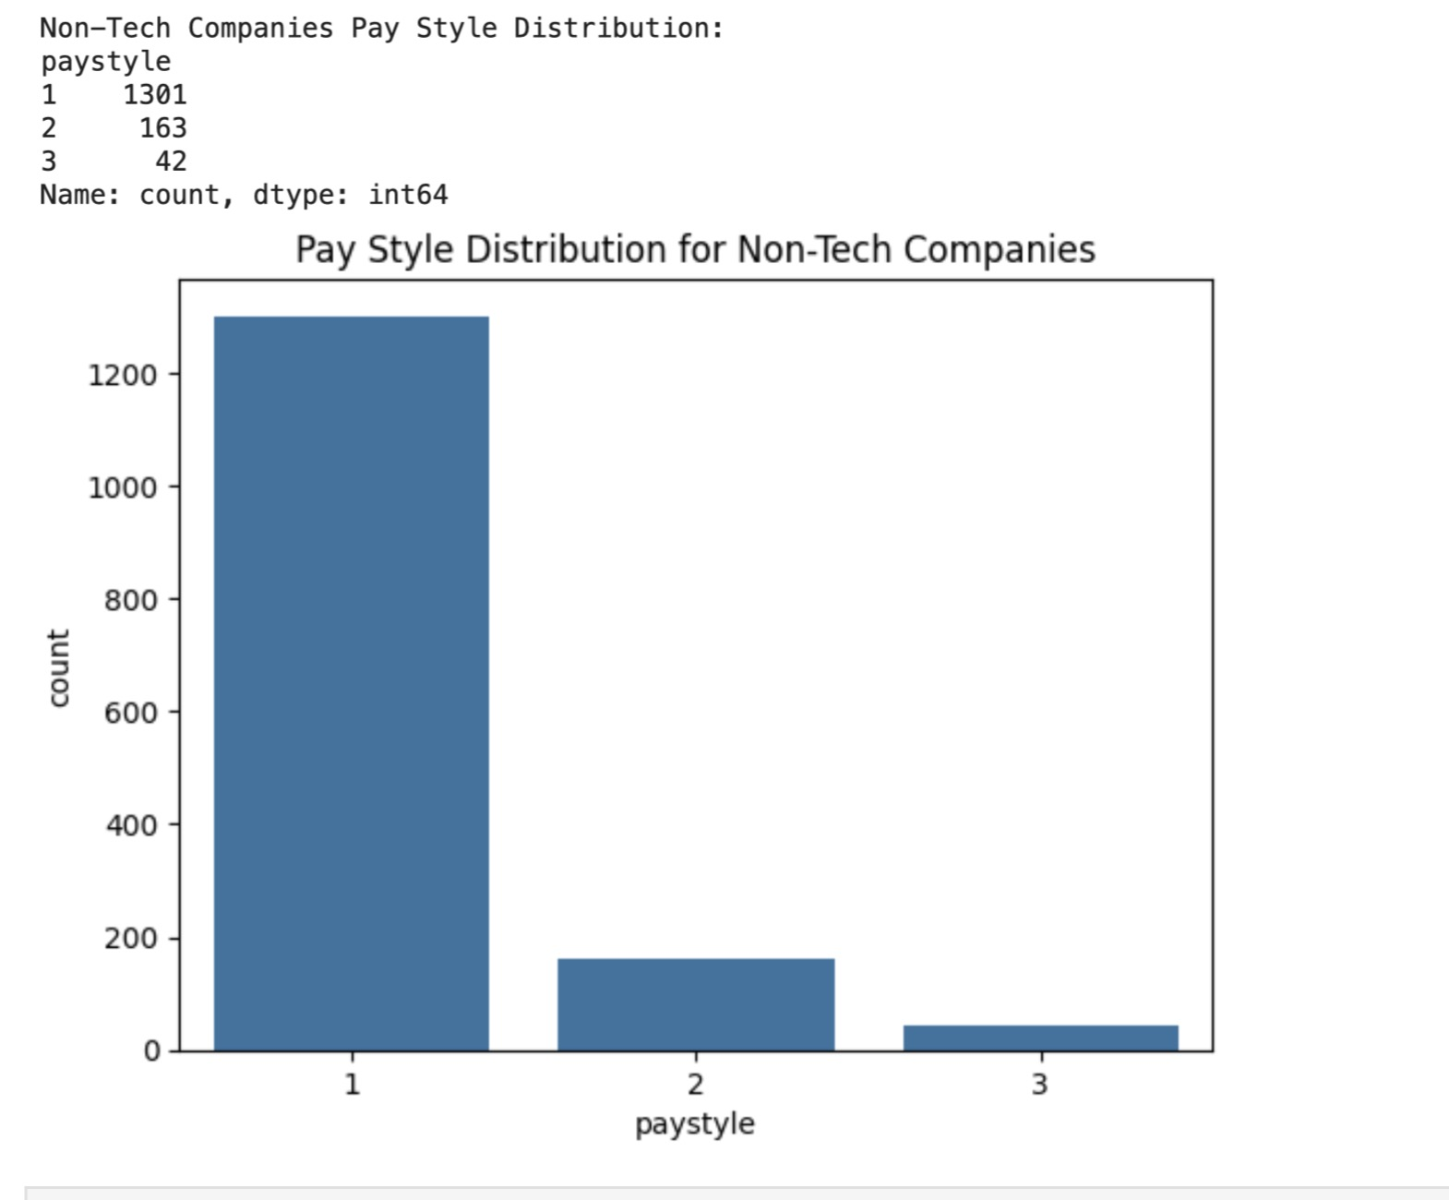

The preference for Installed Payments (Pay Style 1) in both tech and non-tech companies could be due to several reasons:

. Cash Flow Management: Installed payments can provide a predictable and steady cash flow for companies, which is essential for budgeting and financial planning.

. Customer Acquisition: Offering the option to pay in installments could make products or services more accessible to a broader range of customers, particularly if the product or service has a high upfront cost.

. Retention: Installment plans can create a longer-term relationship with customers, as they may be more likely to remain engaged with the company throughout the payment period.

For tech companies specifically, the preference for Pay Style 1 over Pay Style 3 (Commission Payment) might be due to:

. Predictability of Revenue: Tech companies often prefer the predictability of installed payments, especially those that rely on subscription models, such as Software as a Service (SaaS) businesses.

. Product Type: Tech products can sometimes be complex, high-value items where the value is realized over time, making installed payments more suitable.

For non-tech companies, the significantly higher preference for Installed Payments could be because:

. Product and Service Nature: Non-tech companies might deal with physical goods or traditional services where the cost of goods sold needs to be covered upfront, making installed payments a better fit to recover these costs over time.

. Market Expectation: Non-tech markets may have established norms around payment structures that both companies and consumers are comfortable with and expect.

The lesser preference for Commission Payments (Pay Style 3) across both sectors could be due to the variability and unpredictability of income, which can make financial planning more challenging and potentially lead to unstable revenue streams. Commission models are often tied to performance metrics, which can fluctuate and are not guaranteed.

The data indicates that tech companies have a more even distribution among the three payment styles compared to non-tech companies, which heavily favor Pay Style 1. This could suggest that tech companies are more flexible and innovative in their payment offerings, while non-tech companies may be more traditional and conservative in their approach to payments.

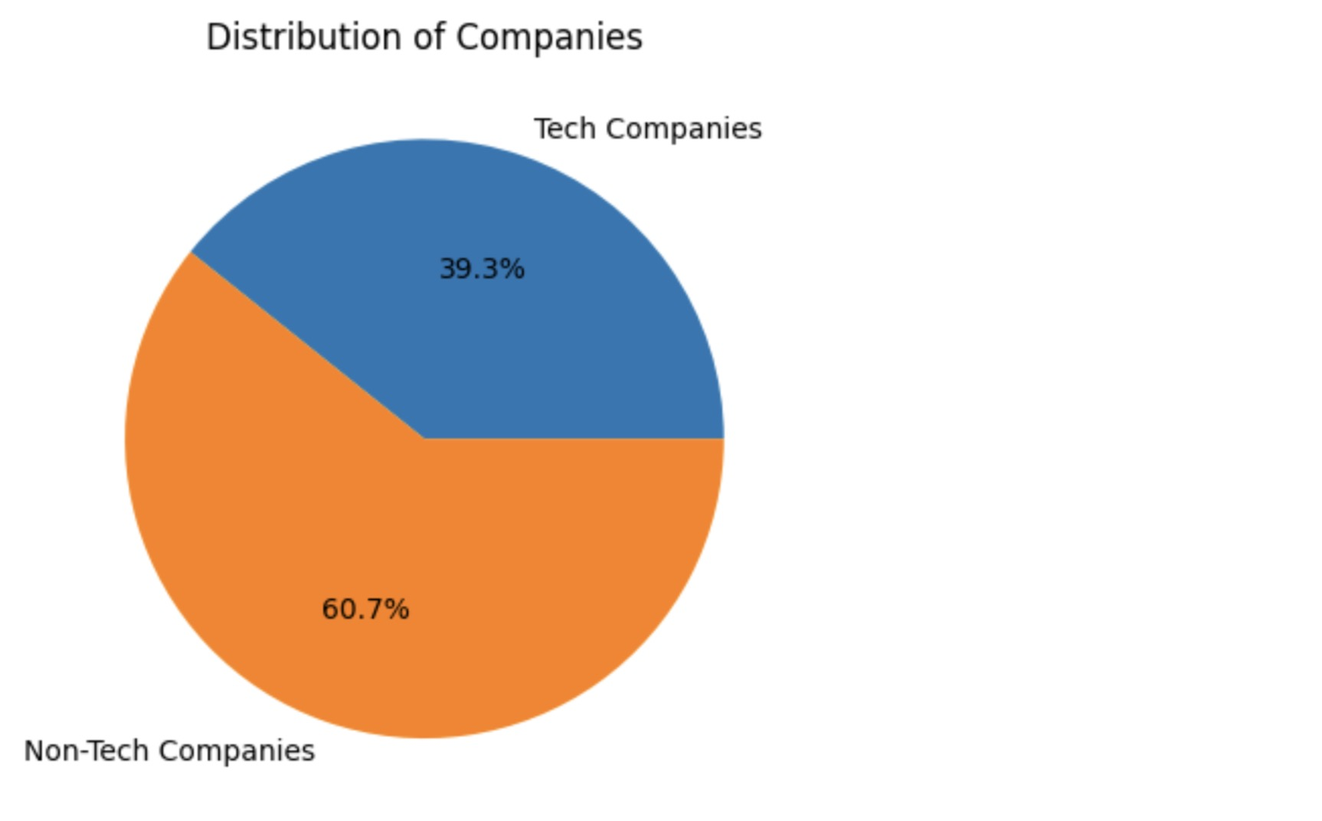

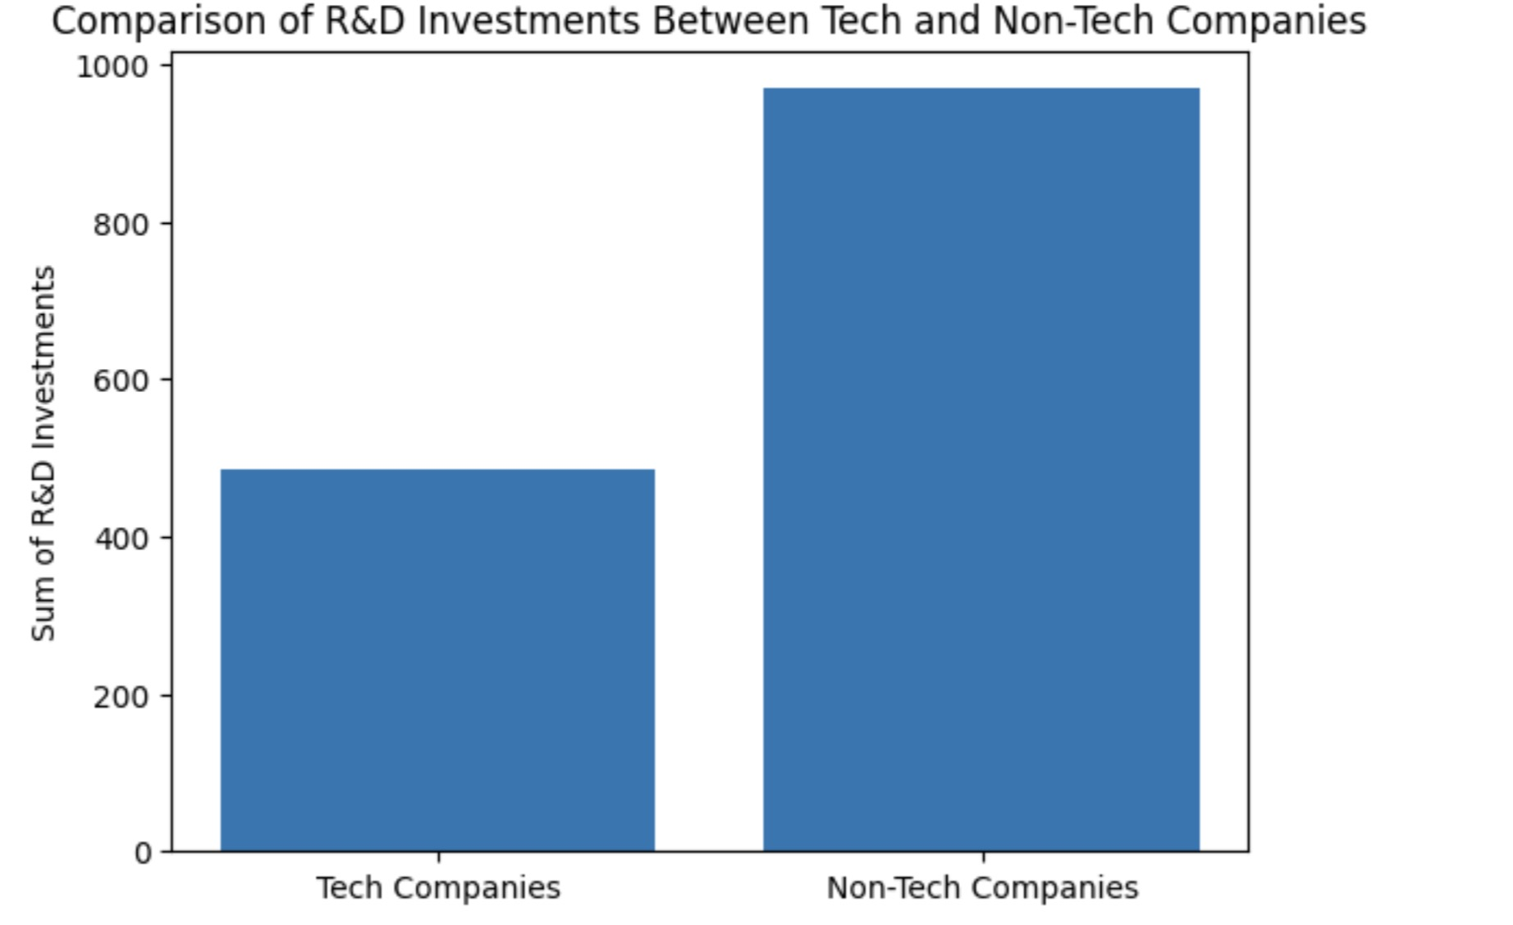

The provided images are bar and pie charts showing the distribution of companies into tech and non-tech, and comparing their R&D investments. Even though tech companies are fewer in number (39.3%), they might have a smaller sum of R&D investments than non-tech companies because:

1. \*\*Scale and Scope\*\*: Non-tech companies might be larger in size and operate in industries where R&D requires more capital investment (like pharmaceuticals or manufacturing).

2. \*\*R&D Intensity\*\*: Tech companies often require less capital for R&D since their developments might be more software-oriented, which can require less investment compared to hardware or physical products. One more thing to add on my 2nd point that 'the tech companies require less capital for RnD since their developments are more software oriented' is that none of the companies here are working heavily on AI like Pika, OpenAI, Runaway. To make companies like this they require a huge investment for processing powers of computers. OpenAI is asking to trying to raise 8 trillion dollars now. They have the best text to video output capabilities. On the otherhand Pika's video generating capabilites are not so good as their investment is also not good. It is less costly to make and ship software products but when the software products come inside a hardware it requires to raise a lot of money for manufacturing and supply chain distribution etc. For example, in early 1990s Next computers had built a very good operating system for softwares but they raised capital to make a physical computer and make the software exculisvely available only in their computers thus more profit. Google and Facebook and many big companies started without much of a big invesment, only in the garage and with few computers of college students.

4. \*\*Lifecycle Stage\*\*: Non-tech companies could be at a different stage in their lifecycle, possibly in a mature or declining stage where they are investing heavily in R&D to innovate and remain competitive.

Professor’s comment: interesting findings, but for point 4, seems a bit strange: firm often invest more R&D in their adolescent stage, as early stage means more profits, charging higher prices

5. \*\*Type of R&D\*\*: The type of R&D investment can differ. Tech companies might invest in incremental innovation, whereas non-tech companies might invest in big, capital-intensive projects.

6. \*\*Industry Standards\*\*: Different industries have different standards and requirements for R&D, with non-tech industries possibly requiring more rigorous testing and validation.

7. \*\*Revenue Allocation\*\*: Non-tech companies might allocate a larger portion of their revenue to R&D in an effort to diversify their products and services or to innovate within traditional industries.

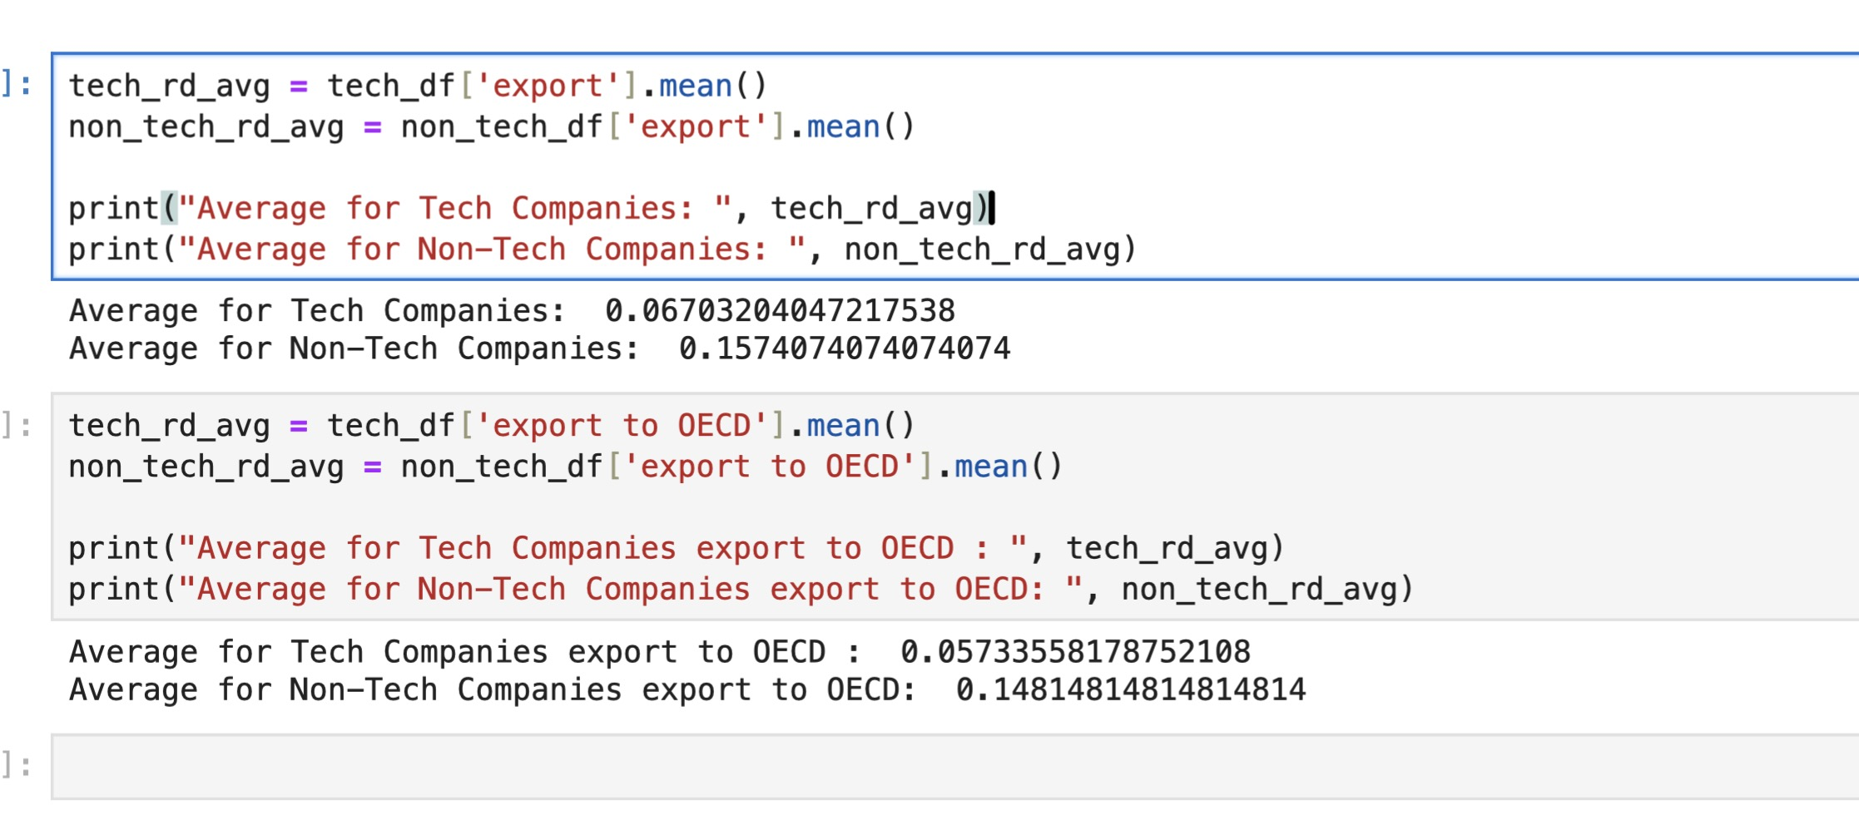

The data indicates a notable difference in export behaviors between tech and non-tech companies. On average, only 6.7% of tech companies are engaged in exporting activities, compared to 15.7% of non-tech companies. Furthermore, when focusing specifically on exports to OECD countries, the trend persists with 5.7% for tech companies and 14.8% for non-tech companies.

Several factors could be contributing to this discrepancy. It appears that tech companies might be more domestically focused or perhaps they are utilizing digital platforms for global reach, which may not be captured as 'exports' in a traditional sense. On the other hand, non-tech companies, possibly dealing with tangible goods, might find a more robust demand for their products in OECD countries, reflecting in their higher export percentages.

Another aspect to consider is the scale and stage of the businesses. The tech sector in the dataset might be composed of smaller or emerging companies, which are not yet exporting extensively, unlike their non-tech counterparts who might be larger and more established, with the necessary infrastructure for international trade.

Regulatory and trade environments could also play a significant role. There may be more complexities or barriers for tech companies exporting to OECD countries, whereas non-tech products might be benefiting from more favorable trade agreements.

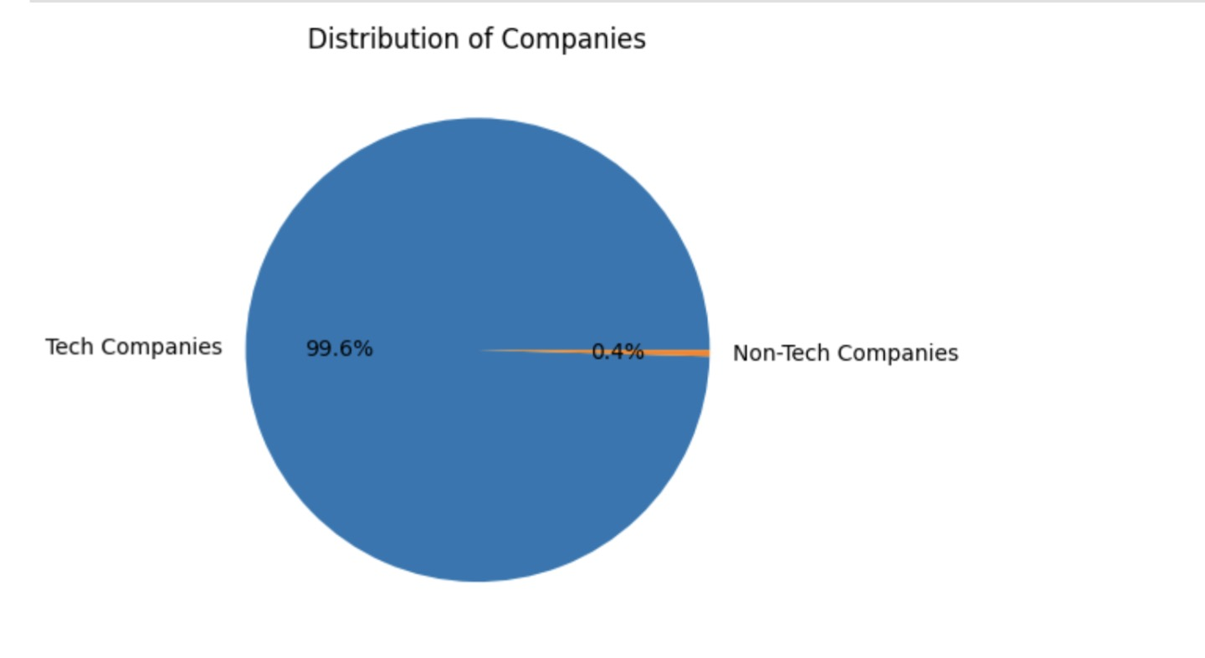

and on the seller list '95%' or more are Tech companies.

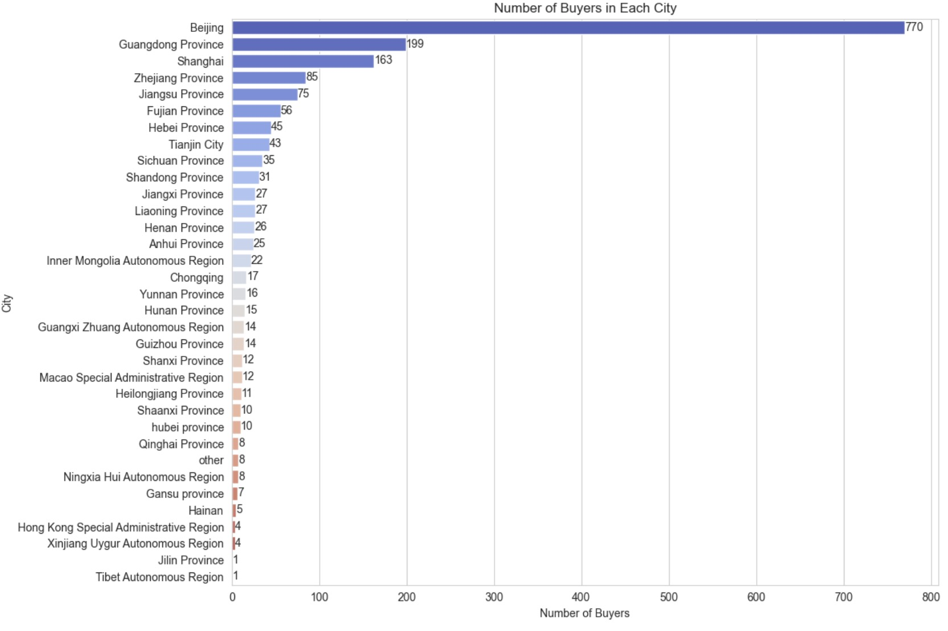

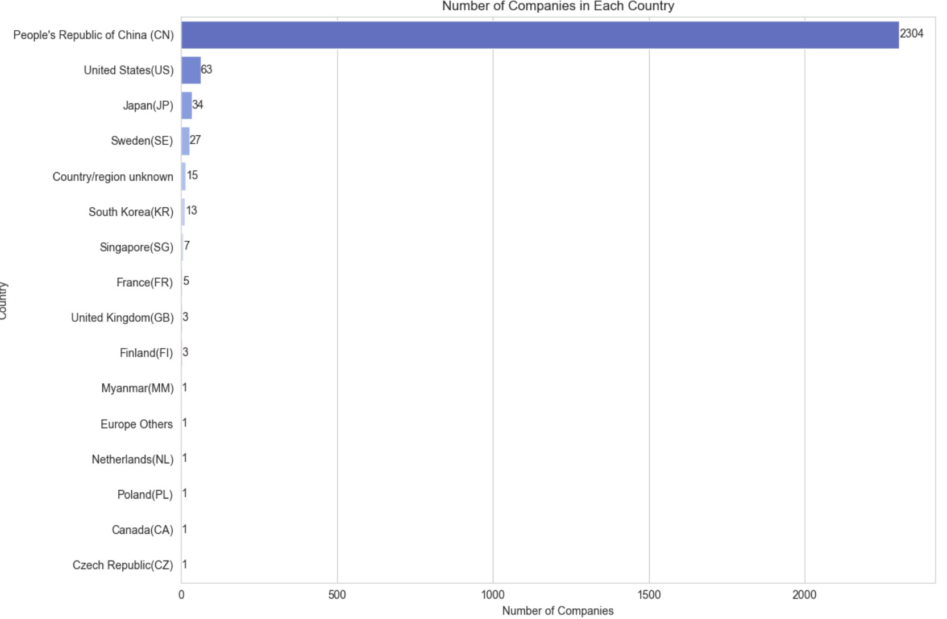

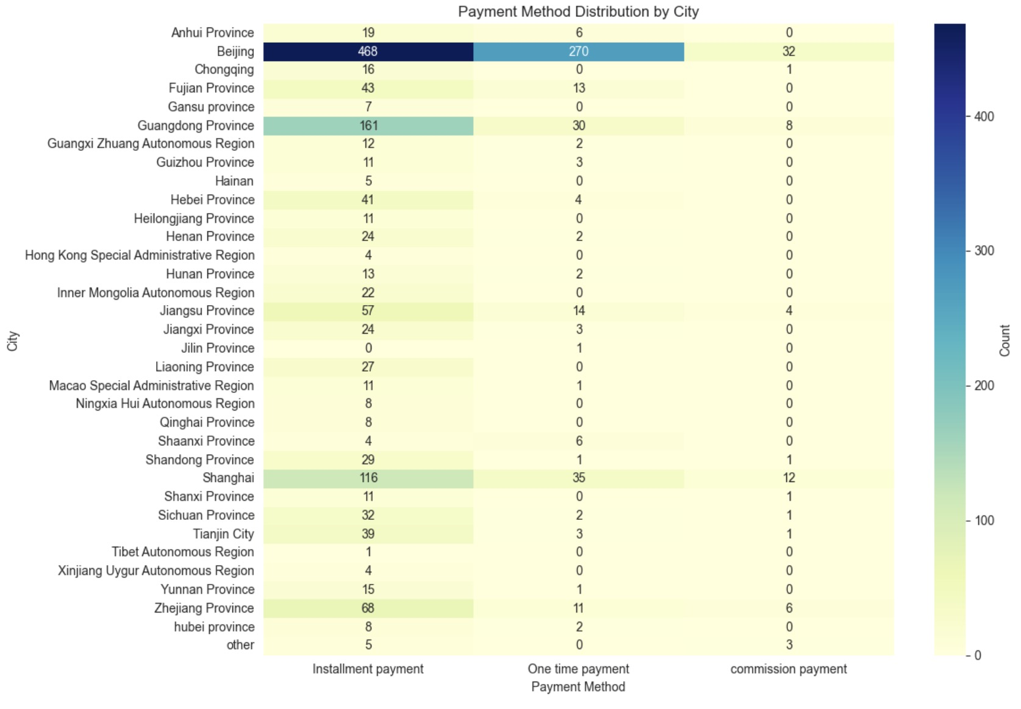

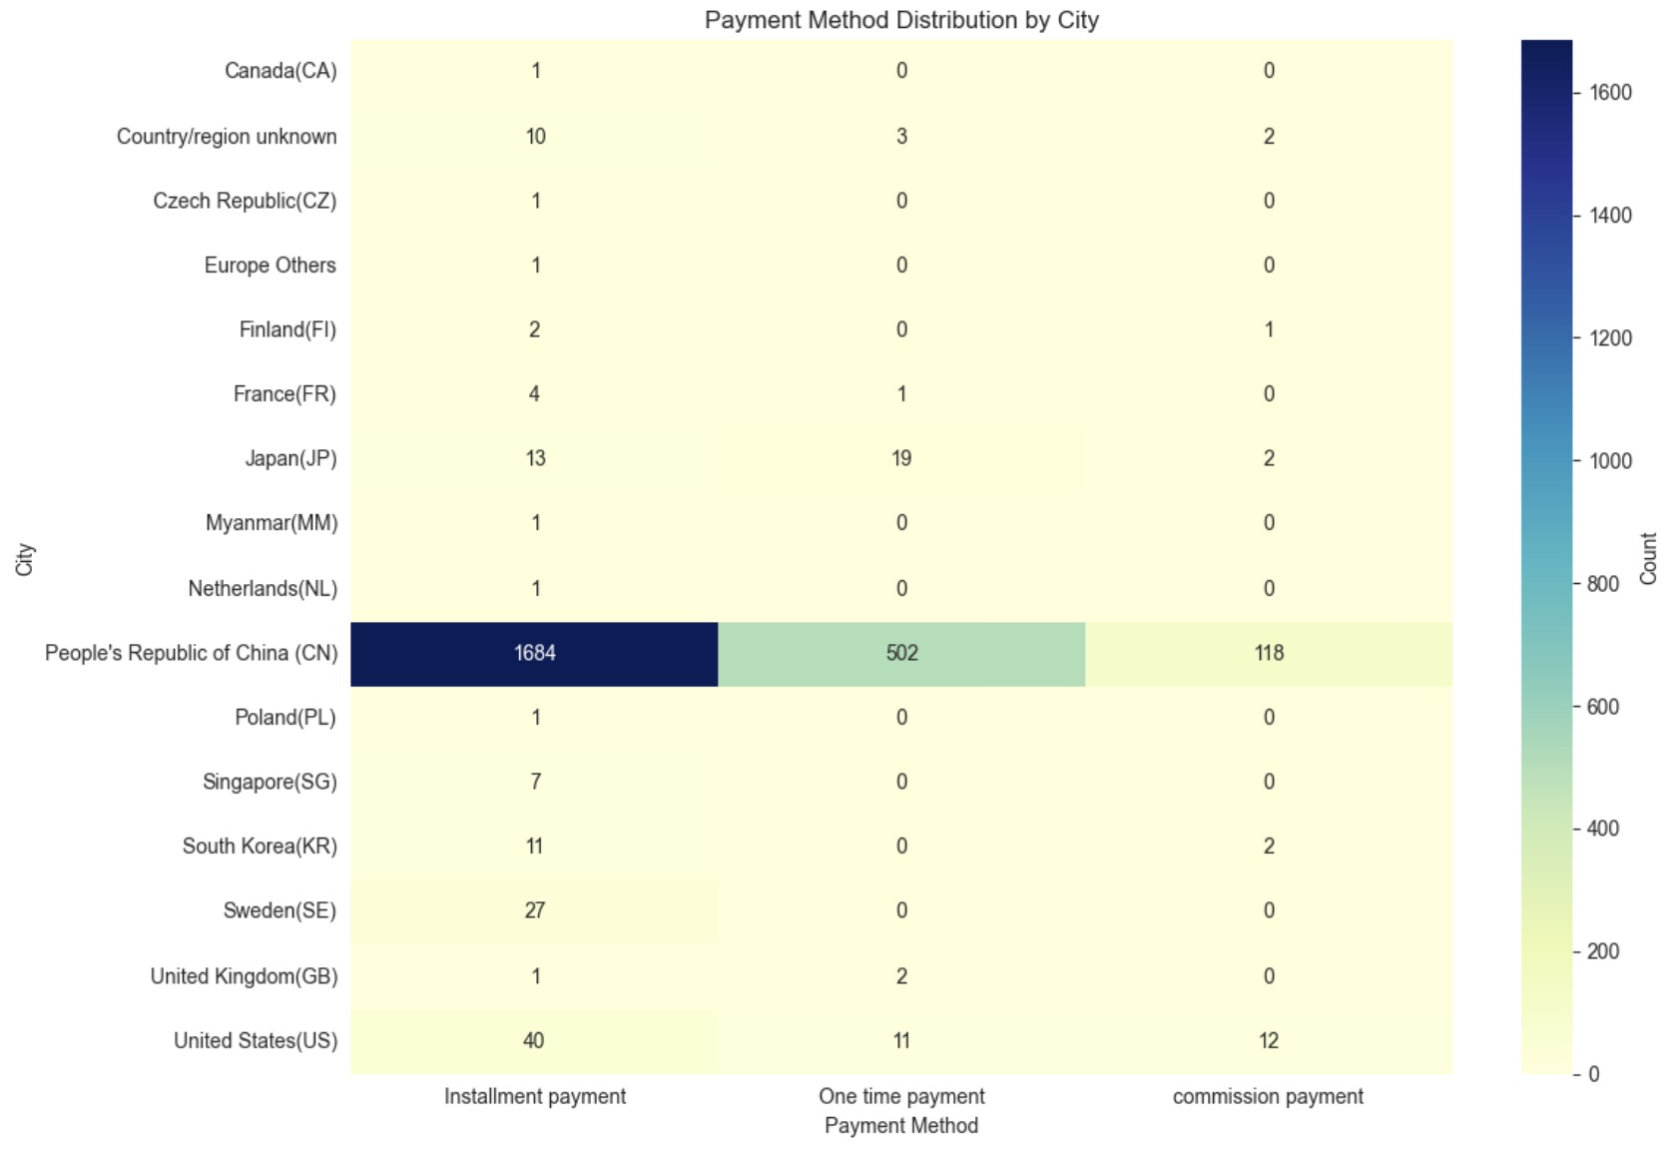

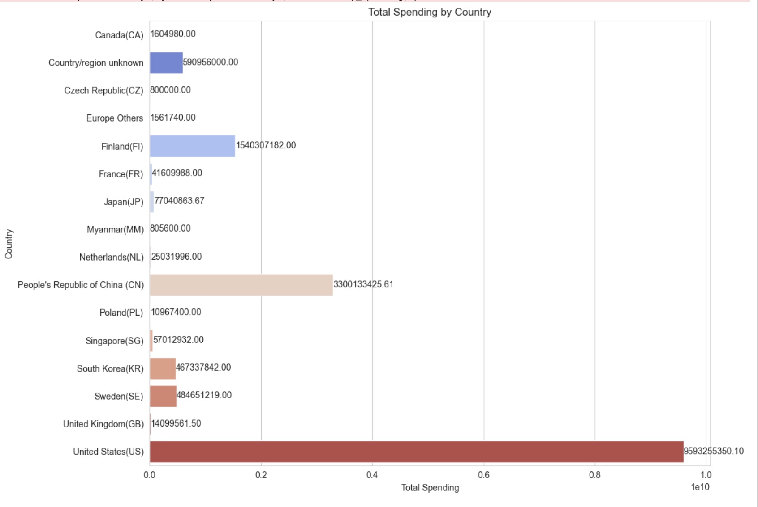

1. The first chart shows the number of buyers in each city within China. Beijing tops the list with 770 buyers, followed by Guangdong Province and Shanghai. The chart indicates a descending order, suggesting that the more industrialized or economically developed the region, the higher the number of buyers.

2. The second chart details the number of companies in each country that have made contracts with companies in Beijing for outsourcing. The People's Republic of China (PRC) has the highest number, indicating that domestic contracts are most common. The United States, Japan, and Sweden follow, suggesting that Beijing has significant outsourcing contracts with these countries.

3. The third chart is a heat map showing the distribution of payment methods by city within China. Beijing has the highest counts across all payment methods, notably in installment payments. This suggests that companies in Beijing prefer installment payments over other methods.

4. The fourth chart is another heat map, this time showing payment method distribution by country. The PRC, again, has the highest numbers across all payment methods, especially installment payments, followed by Japan and the US. This indicates a preference for installment payments in international outsourcing contracts with Beijing.

The possible reasons behind these distributions could include:

- Economic development: More developed regions or countries may have more resources and needs for outsourcing.

- Market size: Larger markets like Beijing have a higher demand for services.

- Business culture: Preferences for payment methods may vary based on business practices and financial strategies in different regions and countries.

- Political and economic relationships: Stronger trade relations between China and countries like the US and Japan may lead to more outsourcing contracts.

The third chart is a heat map representing the distribution of payment methods for outsourcing contracts across various cities within China. Here are some interesting findings from this chart:

- \*\*Beijing's Dominance\*\*: Beijing has an overwhelmingly high number of installment payments (468) compared to other cities, with a significant number of one-time payments (270) as well. This suggests that Beijing, as a major business hub, has a diverse range of outsourcing contracts, and companies there are perhaps more open to or in need of installment payment plans, which could indicate larger contract sizes or longer-term projects.

- \*\*Variation in Payment Preferences\*\*: Other cities, while having fewer contracts overall compared to Beijing, display a variety of preferences for payment methods. For example, Guangdong Province shows a substantial number of installment payments (161), reflecting its status as an economic powerhouse in China.

- \*\*Limited Use of Commission Payments\*\*: Commission payments are very rare across all cities, with the highest count being just 8 in Guangdong Province. This could imply that the nature of outsourced work in China is not typically commission-based, or that such arrangements are not popular.

- \*\*Some Cities with Single Payment Methods\*\*: There are several cities such as Chongqing, Heilongjiang Province, and others where only one type of payment method is recorded (either installment or one-time), which might indicate less flexibility or a standard practice within those regions' outsourcing contracts.

This heat map reveals a lot about the business practices within China, indicating where economic activity is concentrated and what financial arrangements companies are most comfortable with. The heavy inclination towards installment payments in major cities could also suggest a trend of longer-term, trust-based business relationships within the country's outsourcing industry.

The chart presents data on the distribution of different payment methods by city or country. It shows three types of payment methods: installment payment, one-time payment, and commission payment.

The most striking observation is the overwhelming preference for installment payments in the People's Republic of China (CN), with 1,684 instances, followed by a considerable number of one-time payments (502) and commission payments (118). This could suggest a strong consumer market in China where installment payments are favored, possibly due to convenience, credit availability, or purchasing habits.

Other countries, such as Japan (JP), show a balanced distribution between installment payments (13) and commission payments (19), which might indicate a market with diverse payment preferences.

Countries like Sweden (SE), United States (US), and France (FR) show a predominant use of installment payments, with Sweden showing a particularly high number (27) compared to other non-Asian countries, which could reflect a cultural or economic trend in consumer behavior in these regions.

The "Country/region unknown" category has more commission payments (2) compared to installment or one-time payments, which might be due to data categorization issues or specific payment practices in unclassified regions.

The rest of the countries listed have a low count across all payment methods, suggesting either a smaller sample size, less consumer activity, or less prevalence of the business associated with these payment methods in those regions.

The reasons behind these distributions could be influenced by factors such as local financial practices, access to credit, economic stability, consumer confidence, and the nature of goods or services being purchased.

The United States (US) actually has the highest spending on the chart, with a total close to 959 billion. This high expenditure aligns with the US's status as a large economy with high consumer spending.

China's spending appears as a substantial figure as well, but due to the scaling of the chart or the color coding, it may have seemed like a lower amount compared to the US. The high spending in both the US and China could be due to their large populations, strong industrial and technological sectors, and high levels of consumer spending.

Finland's significant total spending is still remarkable and could be due to a variety of factors, such as high-value industries, governmental expenditures, or accounting of multinational corporations' spending attributed to Finland.

Each country's spending can be influenced by a multitude of economic factors, including but not limited to GDP, population, industrial presence, and economic policies that affect spending behaviors.

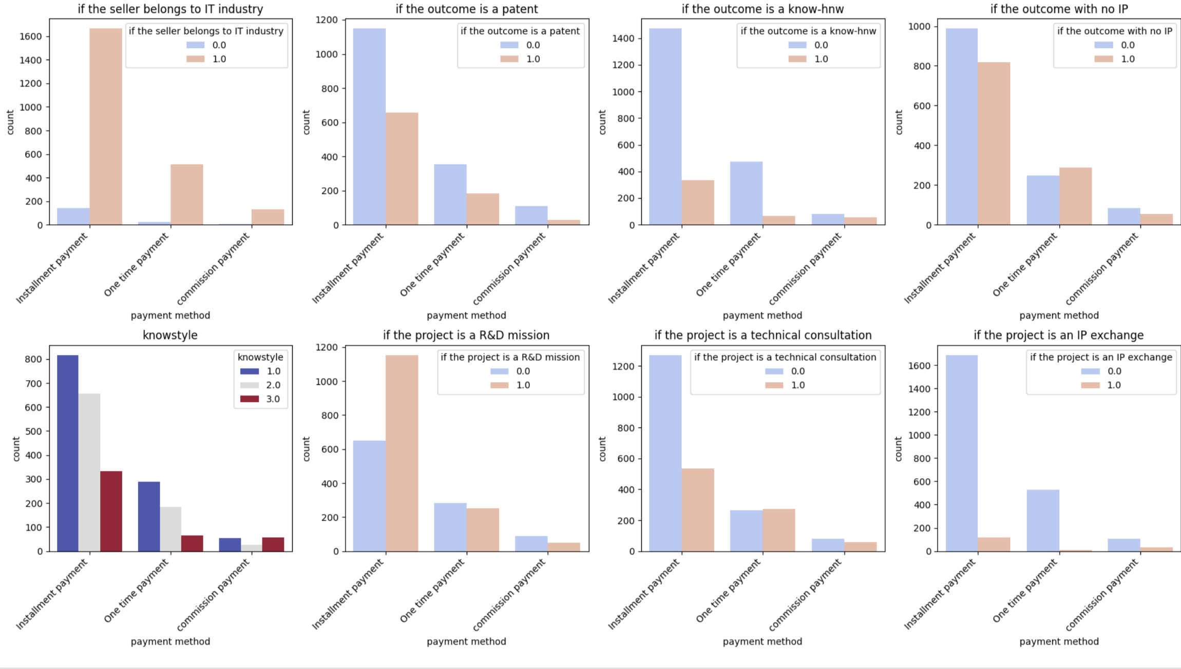

1. \*\*IT Industry Sellers\*\*: Installment payments are preferred when dealing with IT industry sellers. This could be due to the nature of IT projects which may be longer-term and require ongoing maintenance or updates, making installment payments more suitable.

2. \*\*Patent Outcomes\*\*: One-time payments are more common for projects with patentoutcomes. This might be because patents are often the result of specific R&D projects with a clear endpoint, after which a one-time payment can be made for the intellectual property.

3. \*\*Known How-know (know-hnw) Outcomes\*\*: Commission payments are rarely used for known-how outcomes, possibly because such outcomes are lesstangible and harder to value or commission might be difficult to calculate.

4. \*\*No IP Outcomes\*\*: Installment payments dominate when there's no IP involved, which could suggest these projects are service-based or involve continuous delivery where installments make financial planning easier.

5. \*\*Knowledge Style (knowstyle)\*\*: This seems to correlate with payment methods differently, perhaps indicating the complexity or level of customization of the services provided.

6. \*\*R&D Missions\*\*: One-time payments are predominant for R&D missions, likely due to the project-based nature of R&D where funding is often allocated in lump sums.

7. \*\*Technical Consultations\*\*: Installment payments are the majority here, which may be due to the ongoing nature of consultancy services.

8. \*\*IP Exchanges\*\*: One-time payments are most common for IP exchange, suggesting these are transactional events where a single payment is logical and straightforward.

These results could be influenced by the nature of the work, the standard industry practices in Beijing, or the financial management preferences of the companies involved. In more transactional situations (like patents or IP exchanges), one-time payments might be preferred for their simplicity, while in ongoing relationships (like IT services or technical consultations), installments could help with cash flow management. Commission payments seem less common overall, which could be due to the complexity of determining the value of intellectual outcomes like patents or know-how, which doesn't easily lend itself to a commission structure.

1. How many tech companies are exporting and not exporting.

2. under the name of the seller column there are multiple same names. Delete them and make it to one name. The column represents the seller transaction.

3. IT companies if more and non it companies less. Delete the non It companies and focus on the IT companies.

4. Under the seller category check which companies are foreign/local and joint investments.

5. Categorize also the buyers.

6.